Firebrand flux

186 m

0 m

320 m

FBP X

FBP Y

FBP Z

FCS X

FCS Y

FCS Z

Fire line

Road

320 m

160 m

300 m

250 m

150 m

100 m

50 m

Note:

42 types of firebrands including cylindrical, cubic and spherical shapes.

Input total number of firebrands = **7223 pcs/s**

Changes:

Increasing input number of particles up to **2 x 7223 pcs/s**

Increasing wind velocity by adding particles in put velocity at the fire line.

|  |  |  |  |  |  |  |  |  |
| --- | --- | --- | --- | --- | --- | --- | --- | --- |
| Location | Firebrand density (pcs/m2) | | | difference | Flux (pcs/m2.s) | | | difference |
| **Exp** | **7223 pcs** | **2 x 7223 pcs** | **Exp** | **7223 pcs** | **2 x 7223 pcs** |
| FCS X | 335 | 18.5 | 40.6 | 54% | 0.824 | 0.035 | 0.076 | 54% |
| FCS Y | 463 | 168.7 | 433.7 | 61% | 0.902 | 0.364 | 0.937 | 61% |
| FCS Z | 536 | 386.5 | 1014.2 | 62% | 1.361 | 1.154 | 3.027 | 62% |

Firebrand data

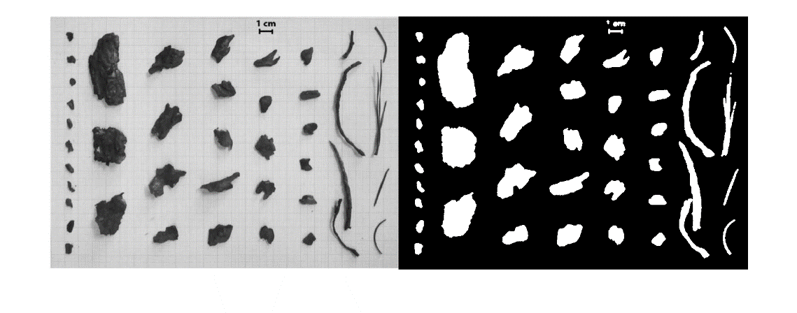

1. Major axis length, minor axis length, eccentricity measured by MATLAB image processing.
2. Shapes determined by eccentricity.
3. Firebrands input numbers were determined according to area classes given in the experimental results.

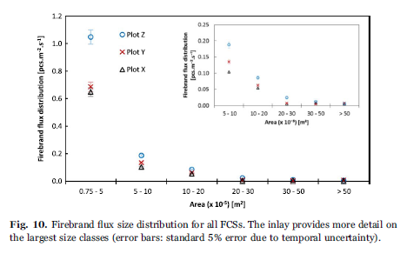

|  |  |  |  |  |  |  |
| --- | --- | --- | --- | --- | --- | --- |
| size (x10-5) m2 | Ember amount (pcs) | | |  |  |  |
| 0.75 to 5 | FCS Z | FCS Y | FCS X | Pcs percentage % | Number of firebrand types | input rate (pcs/s) |
| 5 to 10 | 413 | 352 | 264 | 77.04% | 17 | 7223 pcs x 77% x 17 = 327 |
| 10 to 20 | 74 | 69 | 42 | 13.88% | 13 | 7223 pcs x 14% x 13 = 77 |
| 20 to 30 | 34 | 32 | 22 | 6.54% | 7 | 7223 pcs x 6.5% x 7 = 67 |
| 30 to 50 | 9 | 4 | 2 | 1.15% | 2 | 7223 pcs x 1.2% x 2 = 42 |
| >50 | 5 | 2 | 3 | 0.76% | 2 | 7223 pcs x 0.76% x 2 = 27 |
| size (x10-5) m2 | 2 | 4 | 2 | 0.63% | 1 | 7223 pcs x 0.63% x 1 = 45 |
| Total | 536 | 463 | 335 |  | 42 |  |

|  |  |  |  |  |
| --- | --- | --- | --- | --- |
| Index | Shape | Area (m2) | Size class (x10-5)m2 | Input rate pcs/s |
| 1 | cylindrical | 2.57E-05 | 0.75 -5 | 327 |
| 2 | cylindrical | 2.73E-05 | 0.75 -5 | 327 |
| 3 | cylindrical | 2.13E-05 | 0.75 -5 | 327 |
| 4 | cylindrical | 2.57E-05 | 0.75 -5 | 327 |
| 5 | cylindrical | 7.26E-04 | >50 | 45 |
| 6 | cylindrical | 1.30E-04 | 10-20 | 67 |
| 7 | cylindrical | 9.11E-05 | 5-10 | 77 |
| 8 | cylindrical | 1.16E-04 | 10-20 | 67 |
| 9 | cylindrical | 1.15E-04 | 10-20 | 67 |
| 10 | cylindrical | 7.37E-05 | 5-10 | 77 |
| 11 | cylindrical | 6.76E-05 | 5-10 | 77 |
| 12 | cylindrical | 3.69E-05 | 0.75 -5 | 327 |
| 13 | cylindrical | 1.69E-04 | 10-20 | 67 |
| 14 | cylindrical | 1.81E-04 | 10-20 | 67 |
| 15 | cylindrical | 6.69E-05 | 5-10 | 77 |
| 16 | cylindrical | 3.75E-05 | 0.75 -5 | 327 |
| 17 | cylindrical | 8.55E-05 | 5-10 | 77 |
| 18 | cylindrical | 3.36E-05 | 0.75 -5 | 327 |
| 19 | cylindrical | 2.29E-05 | 0.75 -5 | 327 |
|  |  |  |  |  |
| 20 | cubic | 2.49E-05 | 0.75 -5 | 327 |
| 21 | cubic | 2.71E-05 | 0.75 -5 | 327 |
| 22 | cubic | 3.19E-05 | 0.75 -5 | 327 |
| 23 | cubic | 2.29E-05 | 0.75 -5 | 327 |
| 24 | cubic | 4.36E-04 | 30-50 | 27 |
| 25 | cubic | 3.04E-04 | 30-50 | 27 |
| 26 | cubic | 2.66E-04 | 20-30 | 42 |
| 27 | cubic | 2.68E-04 | 20-30 | 42 |
| 28 | cubic | 8.34E-05 | 5-10 | 77 |
| 29 | cubic | 8.39E-05 | 5-10 | 77 |
| 30 | cubic | 1.39E-04 | 10-20 | 67 |
| 31 | cubic | 8.18E-05 | 5-10 | 77 |
| 32 | cubic | 4.96E-05 | 0.75 -5 | 327 |
| 33 | cubic | 5.25E-05 | 5-10 | 77 |
| 34 | cubic | 4.29E-05 | 0.75 -5 | 327 |
|  |  |  |  |  |
| 35 | spherical | 2.92E-05 | 0.75 -5 | 327 |
| 36 | spherical | 2.12E-05 | 0.75 -5 | 327 |
| 37 | spherical | 2.64E-05 | 0.75 -5 | 327 |
| 38 | spherical | 7.70E-05 | 5-10 | 77 |
| 39 | spherical | 1.58E-04 | 10-20 | 67 |
| 40 | spherical | 7.39E-05 | 5-10 | 77 |
| 41 | spherical | 6.79E-05 | 5-10 | 77 |
| 42 | spherical | 5.67E-05 | 5-10 | 77 |

Number of firebrands landed from each firebrand type on X, Y, Z location and firebrand mass (mg)

Douglas fir tree burning 5.6 m

Summary of experiment

9 Douglas fir trees were burnt

3 X 5.2 m Douglas fir trees

* Varying moisture contents (18%,21%,23%).
* Measured firebrands from 3 of them.

6 X 2.6 m Douglas fir trees

* Varying moisture contents (10%, 21%,>50%).
* Measured firebrands from 3 of them.

Temporal mass data of the tree taken from the experiment and plotted to get the mass loss rate of 5.2 m tree with 18% MC:

|  |  |
| --- | --- |
|  |  |

Heat of combustion = 17 700 kJ/kg (found averaging Douglas fir wood and foliage measurements)

Available data from the experiment

|  |  |  |
| --- | --- | --- |
| **Information** | Douglas fir tree 1 | Douglas fir tree 2 |
| Height (m) | 2.6 | 5.2 |
| Girth (m) | 1.5 | 3.0 |
| MC (%) | 10 | 18 |
| Initial mass (kg) | 10.5 | 53 |
| Mass loss (kg) | 6.5 | 24 |
| Mass loss rate | Available | Available |
| Mass of collected firebrands (g) | 18 | 50 |
| Firebrands’ dimensions  (length, width, mass percentage) | Available from the data received by Manzello and his papers. | Available from the data received by Manzello and his papers. |

|  |  |  |
| --- | --- | --- |
| Tree height (m) | MC % | Peak mass loss rate (kg/s) |
| 2.6 | 10 | 0.4 |
| 5.2 | 23 | 1.4 |
| 5.2 | 18 | 2.02 (from the above mass loss rate plot) |

**Fig 6 (a) FAM paper firebrand data for each test (different MC)

**5.2 m Douglas fir tree MC 23% data (include the ref of the paper)

**5.2 m Douglas fir tree MC21% data (include the ref of the paper)

**2.6 m Douglas fir tree MC 21% data (include the ref of the paper)

Firebrand data

Total 211 firebrands were collected in 3 burning experiments.

According to Douglas fir 2.6 m 10MC tree burning simulation,

Total heat release =53 237 KJ

Total mass loss =4.449 kg

Average heat release rate (10 seconds to 34 seconds) = 1602 kW

Number of total input firebrands = 347 pcs

Number of collected firebrands = 70 pcs

Average of input firebrands =10.52 pcs/s (347/33 s)

Input number vs HR = $\frac{average input number of firebrands}{HRR}$

= $\frac{10.52 pcs/s}{1.602 MW}=6.56 pcs/MJ$

*measured same number of firebrands(211pcs) same as the smaller tree. Individual firebrands’ mass values are higher (bigger firebrands)